**GLM tips: get non-linear with splines**

This tip is great for a quick non-linear test, before you go all the way  
with a GAM or parametric non-linear model.

You’ll need the splines library, which comes shipped with R anyway.

First, let’s make up a bit of count data. The underlying ‘true’ model  
will be poisson (think count data) with a log link (so slope estimates  
are multiplicative of the poisson mean). But we’ll introduce a bit of  
non-linearity.

n <- 100

set.seed(101)

x <- sort(rnorm(n, sd = 2))

mu <- 2 + 0.1*x - 0.6*x^2 + 0.18*x^3#linear predictor

y <- rpois(n, exp(mu))

plot(x, y)

lines(x, exp(mu))

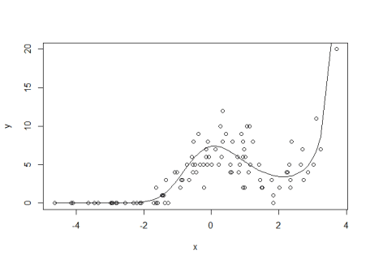

Now, we could just fit a polynomial, but for real data we wouldn’t know  
the mean structure was generated as a polynomial. So we might want to  
use something a bit more flexible, like a cubic spline.

So, here’s how to make a cubic spline. We just need to choose the  
degrees of freedom. A DF of of 1 will give us a linear fit, higher DFs  
allow more bends (‘knots’). We’ll fit a log-linear model, a model with  
df = 2 and a model with df= 3 Given we generated our data with a cubic  
polynomial, we’d expect the 3 df model will do best

library(splines)

#log linear model

m1 <- glm(y ~ x, family = "poisson")

m1pred <- predict(m1, type = "response")

#non-linear models

m2 <- glm(y ~ ns(x,2), family = "poisson")

m2pred <- predict(m2, type = "response")

m3 <- glm(y ~ ns(x,3), family = "poisson")

m3pred <- predict(m3, type = "response")

par(mfrow = c(1,3))

plot(x, y, main = "DF = 1")

lines(x, exp(mu), lwd = 2, col = "grey")

lines(x, m1pred, col = "orange", lwd = 2)

plot(x, y, main = "DF = 2")

lines(x, exp(mu), lwd = 2, col = "grey")

lines(x, m2pred, col = "purple", lwd = 2)

plot(x, y, main = "DF = 3")

lines(x, exp(mu), lwd = 2, col = "grey")

lines(x, m3pred, col = "darkblue", lwd = 2)

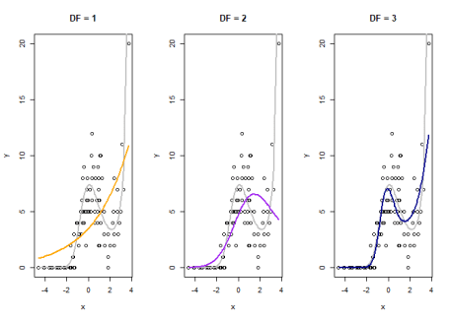  
The orange line is the naive linear fit, it basically shows no trend.  
The purple line (df = 2) does better, but misses the kick up at the end.  
The blue line looks closest to the ‘true’ mean function (grey line).

The purple and blue lines are our spline fits with 2 and 3 knots  
respectively. Both clearly capture the non-linearity. The grey line is  
the ‘true’ mean structure we created above. So our splines just peaks a  
bit too hard, but does get the shape right.

We can convince ourselves that the 3 df splines model is better with AIC

AIC(m1)

## [1] 492.1094

AIC(m2)

## [1] 434.6807

AIC(m3)

## [1] 362.3653

Yep, the 3 spline model has a much lower AIC despite using more model  
D.F., so is better.

**Transfer your spline skills, anywhere**

A nice feature of this cubic spline trick is that you can use it  
anywhere that takes a model matrix as input. So it will work with glm,  
glmer, lmer and any Bayesian GLM method you care to use. Just apply  
your normal model selection criteria to find the ‘best’ number of knots.

First, set the knots using x:

library(splines)

xcs <- ns(x, 3) #3 knots!

head(xcs, 3)

## 1 2 3

## [1,] 0.00000000 0.0000000 0.00000000

## [2,] -0.04388799 0.1157184 -0.07117461

## [3,] -0.04775128 0.1262731 -0.07766646

plot(x, xcs[,1], type = 'l', ylim = c(min(xcs), max(xcs)))

lines(x, xcs[,2], col = "salmon")

lines(x, xcs[,3], col = "steelblue")

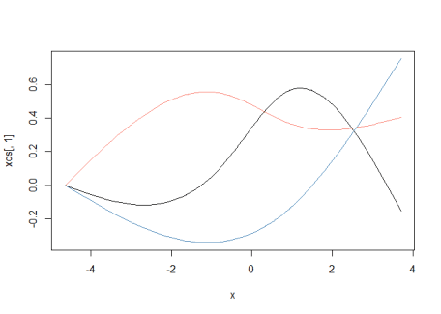

This splits x into three covariates (note the new matrix xcs has  
three columns), which I’ve plotted above. The cubic spline algorithm  
puts bends in the new covariates according to the density of the data.

We can use these new covariates in our model and glm will estimate a  
coefficient for each one.

Because the xcs are a non-linear functions of x, fitting a model  
against them means we can mix the curves to get a non-linear fit. We do  
lose a few degrees of freedom though, because now x is three covariates,  
instead of just one.

We can just use xcs in our model formula as a covariate.

But I prefer just to put the ns command directly into the model  
formula, that way it is easy to change the knots, as we did above.

**What about GAMs?**

If you really want to get into non-linear trend fitting, you should use  
a generalized additive model (GAM), such as from package mgcv.

In fact, GAM can fit these kind of splines for you too (and more), it  
just uses a different method to select the number of knots.

But the splines trick is still handy. For instance, you can quickly  
modify an existing linear model to have a non-linear spline. Or use it  
in a Bayesian linear model that doesn’t have a GAM equivalent and use them in  
Bayesian models if you want other types of splines).

So I hope you enjoying splining.